WEEK 1

**Topic -**

Week 1 – Getting started with Xcode

**Snapshots -**

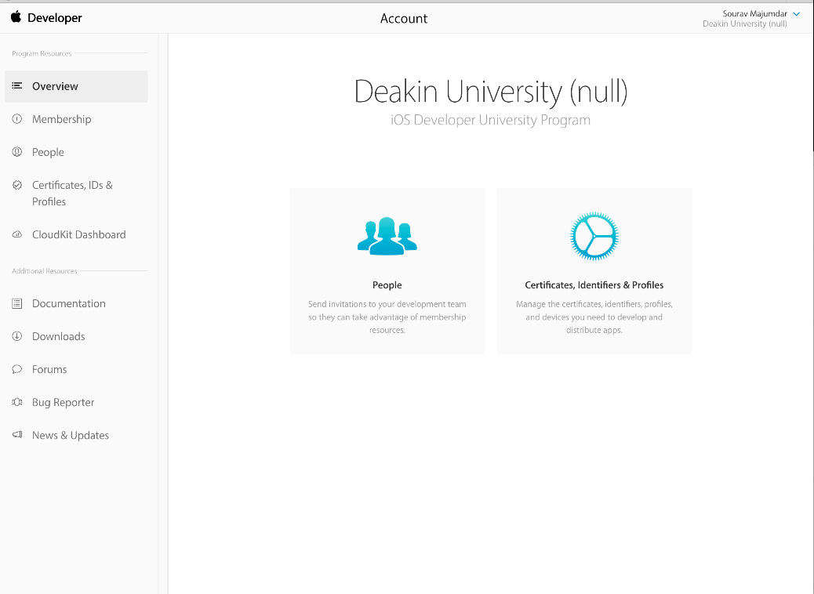

Fig 1: Snapshot depicting the successful creation of an apple developer account.

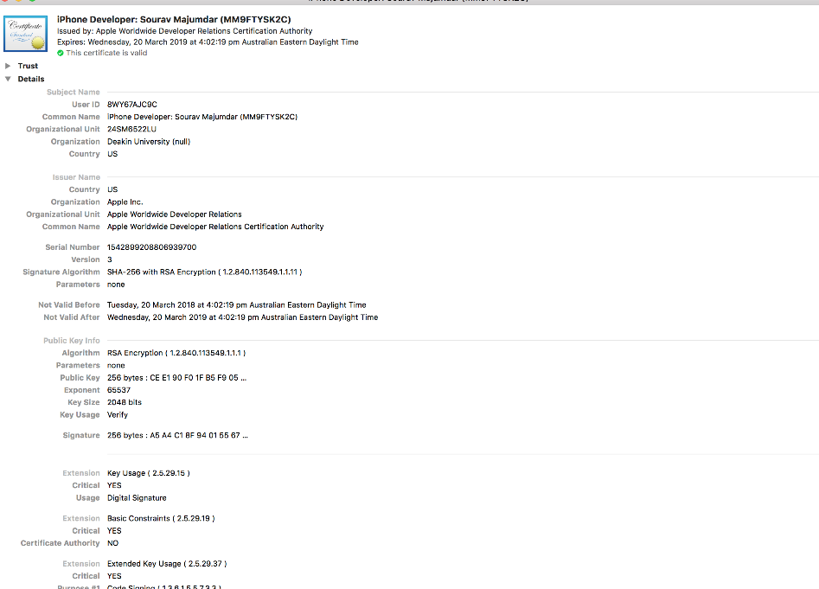

Fig 2: Snapshot depicting my developer certificate.

**How I implemented -**

Firstly, we were supposed to create an Apple developer account with the help of the code that was provided to us in a mail from the unit chair. As I already had an apple account I did not had to go through the registration process of creating an apple ID. Then I had to agree with some agreements and type in the invitation code. Once the invitation code was validated I was successfully added to the university developer team. Next step was to get a certificate, hence in the launchpad I searched for the key chain access where I had to request a certificate from the certificate authority by filling in some credentials, so that my csr file could be downloaded.

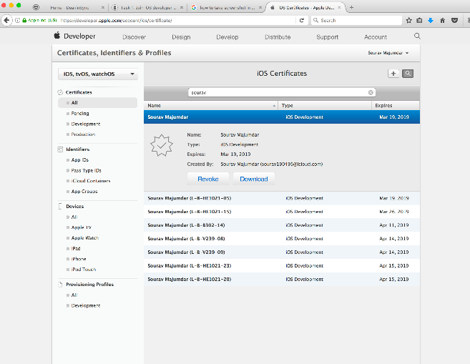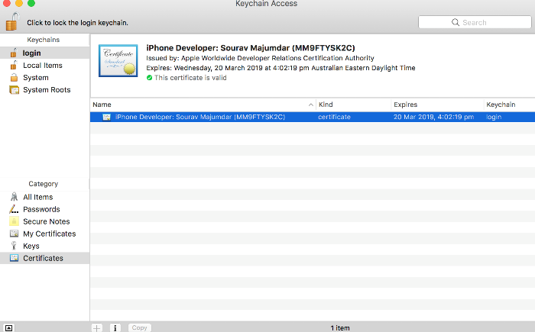

Fig 3: Snapshot depicting key chain access.

Once my csr file was downloaded I had to upload that to the member center of my apple developer account. Once uploaded and approved by the unit chair I was able to download my certificate from my account and installed it in my computer.

Fig 4: Snapshot showing the certificate download window.

For connecting my device for development I connected my iphone to the computer and found out the UDID with the help of the lab tutor. The from my developer account I had to download my provisioning profile in the MAC. Once download I started to use my iphone as a simulator instead of the simulators provided by xcode.

**Reflection -**

Overall, first week was a very exciting experience for me. Especially because this subject particularly was new for me as I had never used MAC computers before and the fact that we were going to start with application development from next week made the experience more special. Initially while doing the lab I was little bit confused as other students were able to finish the tasks way ahead of me and I was lagging behind but the tutor helped me a lot and I was gradually able to understand what I was doing. Once everything was done I started to play around with xcode, I was exploring different features and trying to familiarize with the new terms like UIViewController, main story board and lot other new things. With so many features it was looking difficult initially but as weeks progressed everything became easier. It was a nice first week and everything was set up for the coming weeks.